

*[Journal Name]*

Supporting Information for

**[Title of article, exactly following journal article]**

[Author List, exactly following journal article]

[Institutional affiliations]

**Contents of this file**

Text S1 to Sx

Figures S1 to Sx

Tables S1 to Sx

**Additional Supporting Information (Files uploaded separately)**

Captions for Tables S1 to Sx (if larger than 1 page, upload as separate file)

Captions for Movies S1 to Sx

Captions for Audio S1 to Sx

**Introduction**

[Type or paste your text here. The introduction gives a brief overview of the supporting information. You should include information about as many of the following as possible (when appropriate):

* a general overview of the kind of data files;
* a general description of processing steps used;
* any known imperfections or anomalies in the data.]

***Delete all unused file types below. Copy/paste for multiples of each file type as needed.***

**Text S1. More detailed methodology to derive dust fractional iron solubility fields.**

Type or paste text here. This should be additional explanatory text, such as: extended descriptions of results, full details of models, extended lists of acknowledgements etc. It should not be additional discussion, analysis, interpretation or critique. It should not be an additional scientific experiment or paper.

***Repeat for any additional Supporting Text***

<Insert Figure S1>

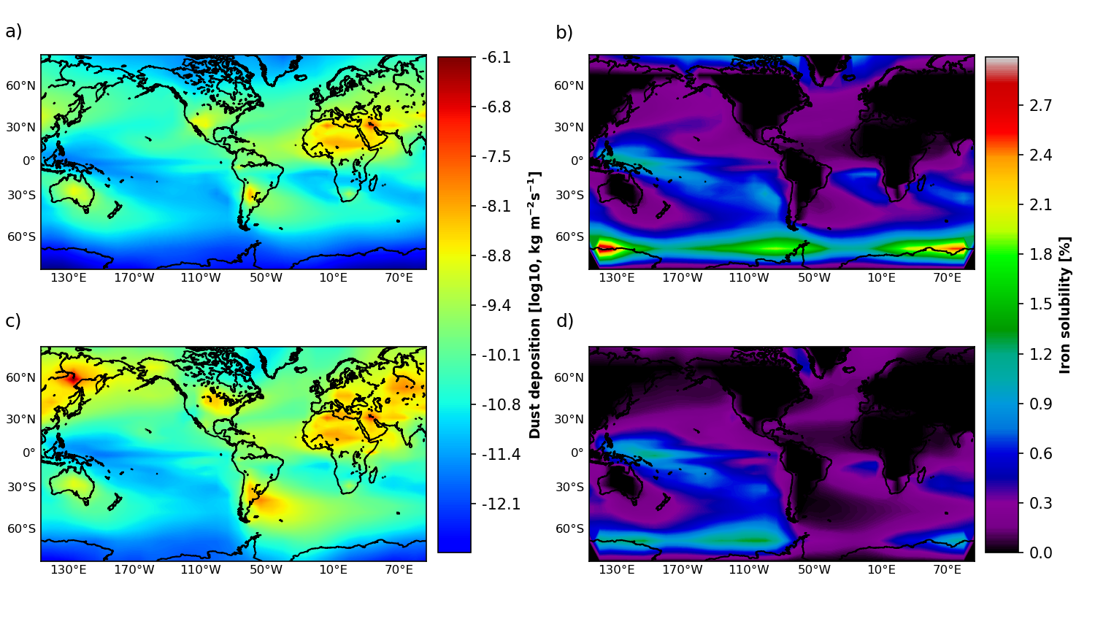

**Figure S1.** Type or paste caption here.

***Repeat for any additional Supporting figures***

<Insert Table S1> If table is large, upload as separate file but include caption in this document. Keep table captions in numerical order; it is acceptable to mix tables with captions and captions only (with files uploaded separately) in this document.

**Table S1.** Model parameters.

| **Symbol** | **Parameter** | **Value** |
| --- | --- | --- |
|  | Fe dust solubility | Variable |
| RFe | Fe:P ratio | 0.47 nmol:1 mol |
|  | Fraction of DOM | 0.66 |
| bio | Biological uptake time scale | 63.3827 yr |
|  | Remineralization rate | 0.5 yr-1 |
| KFe | Iron half saturation constant | 0.1 nM kg-1 |
| KPO4 | Phosphate half saturation constant | 0.1 uM kg-1 |
| I0 | Light half saturation constant | 40 W m-2 |
| ksv | Scavenging rate | 1.44x10-6 Mol-1 m2 |
|  | Scavenging scaling rate | 0.1 |
| KFeL | Ligand stability constant | 1x10-11 M-1 |

***Repeat for any additional Supporting tables***

**Data Set S1.** Type or paste caption here (upload your dataset(s) to AGU’s journal submission site and select “Supporting Information (SI)” as the file type. Following naming convention: ds01.

***Repeat any additional Supporting movies***

**Audio S1**.Type or paste caption here (upload your audio file(s) to AGU’s journal submission site and select “Supporting Information (SI)” as the file type. Following naming convention: auds01.

***Repeat for any additional Supporting audio files***